1. Service is a normal Typescript class no need for @Service as for component (@Component) and for directive (@Directive).
2. 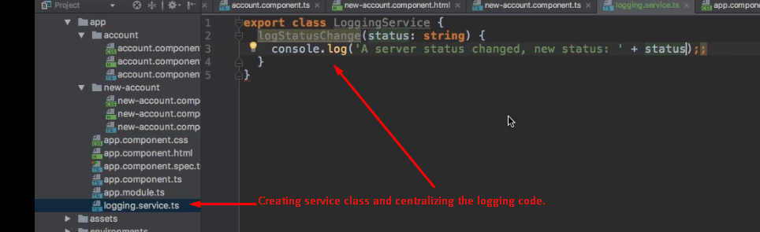
3. 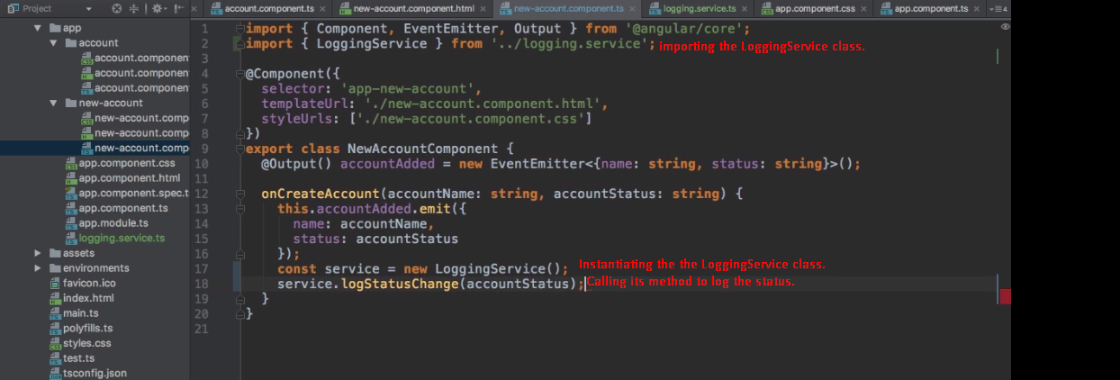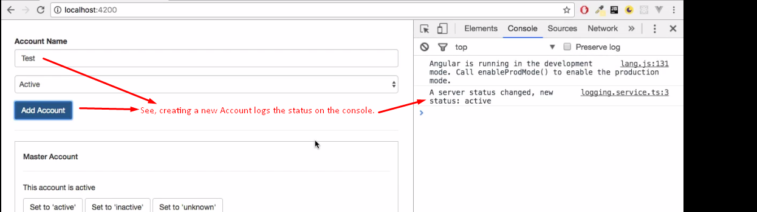
4. **NOTE**: This is not the way we create service instance in angular. Angular provides a much better way to getting access to service.
5. **Let’s** see how to create service in angular in next video.